King Arthur Flour Baking Contest
Junior
Doughnut Muffins
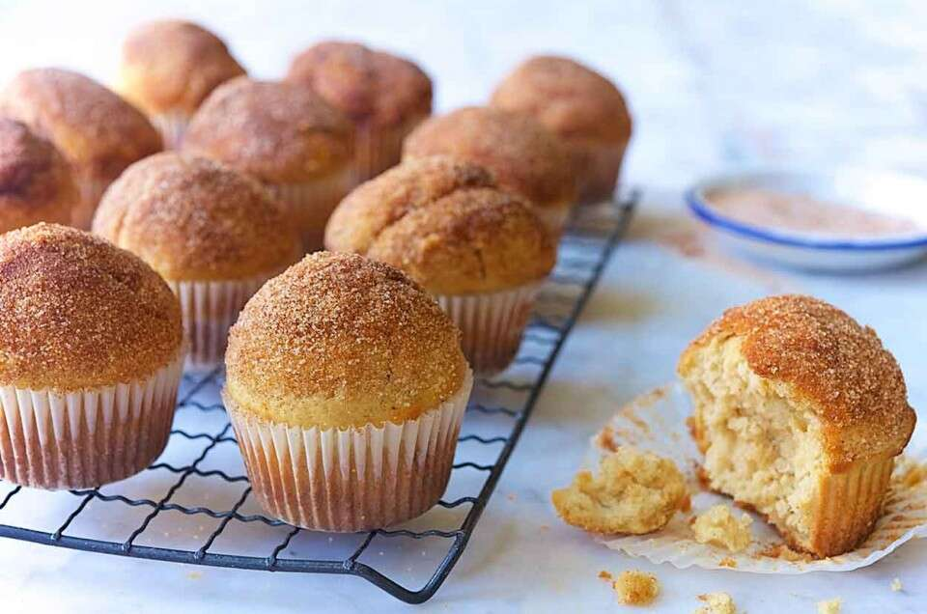

Ingredients:
Batter:
- 4 Tablespoons Butter
- ¼ Cup Vegetable Oil
- ½ Cup Granulated Sugar
- 1/3 Cup Brown Sugar, Packed
- 2 Large Eggs
- 1 ½ Teaspoons Baking Powder
- ¼ Teaspoon Baking Soda
- 1 to 1 ¼ Teaspoons Nutmeg, to Taste
- ¾ Teaspoon Salt
- 1 Teaspoon Vanilla Extract
- 2 2/3 Cups King Arthur Unbleached All-Purpose Flour
- 1 Cup Milk
Topping:
- 3 Tablespoons Butter, Melted
- 3 Tablespoons Cinnamon-Sugar*
*Make your own cinnamon-sugar by mixing 3 tablespoons granulated sugar with 1 teaspoon cinnamon.

Instructions:
- Preheat the oven to 425° F. Lightly grease a standard muffin tin or line with paper muffin cups.
- In a medium-sized mixing bowl, cream together the butter, vegetable oil, and sugars till smooth.
- Add the eggs, beating to combine.
- Stir in the baking powder, baking soda, nutmeg, salt, and vanilla.
- Stir the flour into the butter mixture alternately with the milk, beginning and ending with the flour and making sure everything is thoroughly combined.
- Spoon the batter evenly into the prepared pan, filling the cups nearly full.
- Bake the muffins for 15 to 17 minutes, or until they’re a pale golden brown and a cake tester inserted into the middle of one of the center muffins comes out clean.
- Remove them from the oven, and let them cool for a couple of minutes, or until you can handle them. While they’re cooling, melt the butter for the topping.
- Use a pastry brush to paint the top of each muffin with the butter, then sprinkle with the cinnamon-sugar. Or simply dip the tops of muffins into the melted butter, then roll in the cinnamon-sugar.
- Cool on a rack. Submit 6 muffins on a disposable plate.

